Subramani P

18/11/2024

PL/SQL Tasks

create database temp_DB;

use temp_DB;

create table employee (

employee_name varchar(20),

emp_experiance numeric,check(emp_experiance <5),

hike_percentage numeric,

emp_role varchar(20));

insert into employee values('subramani',2,25,'Developer'),('Sankar',3,30,'Business analyst'),('Hari',4,27,'Data Analyst');

select * from employee;

-- Question 1 - create a stored procedure that takes a product_id as

-- input perameter and returns the details of that product;

create table product(

product_id numeric,

product_name varchar(20),

qty numeric,

price numeric

);

insert into product values(101,'soap',10,100),(102,'paste',20,35);

DELIMITER //

CREATE PROCEDURE get_detail(in id numeric)

begin

select * from product where product_id = id;

end //

CALL get_detail(101);

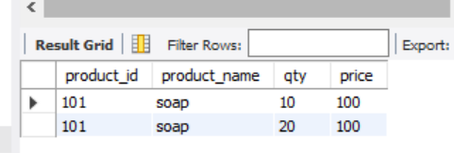

-- IN and out perameter

insert into product values(101,'soap',20,100),(102,'paste',25,35);

delimiter //

create procedure get_data(in id numeric,out total_qty numeric)

begin

select sum(qty) as total_qty from product where product_id = id;

end //

call get_data(101, @product);

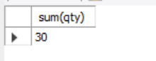

-- in&out method

delimiter //

create procedure multibytwo(inout num numeric)

begin

set num = num* 2;

end //

set @value = 5;

call multibytwo(@value);

select @value;

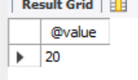

-- Functions

-- Question 2 create a function that takes price as an arguments and returns the details of the

-- products whose price > arguments

delimiter //

create function getproductdemo3(priceofproduct numeric) returns varchar(50)

deterministic

begin

declare pname varchar(50);

select group_concat(product_name separator ', ') as product_name into pname from product where price > priceofproduct ;

return pname;

end //

select * from product

select getproductdemo3(50);

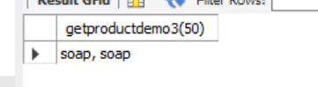

delete from product where qty = 25

-- how to return complete table structure with functions and SP

create function get_fulldataONE()

returns @fulltable table

(pro_id numeric,p_name varchar(50),price numeric,qty numeric)

as

begin

insert into @fulltable

select * from from product;

return

end

SELECT get_fulldataONE()

select * from product;

DELIMITER //

create procedure product_detail()

begin

select * from product;

end //

CALL product_detail()

